**Project 5**

**Scheduling a basic job in Jenkins**

**Ss1: Jenkins home page with job list**

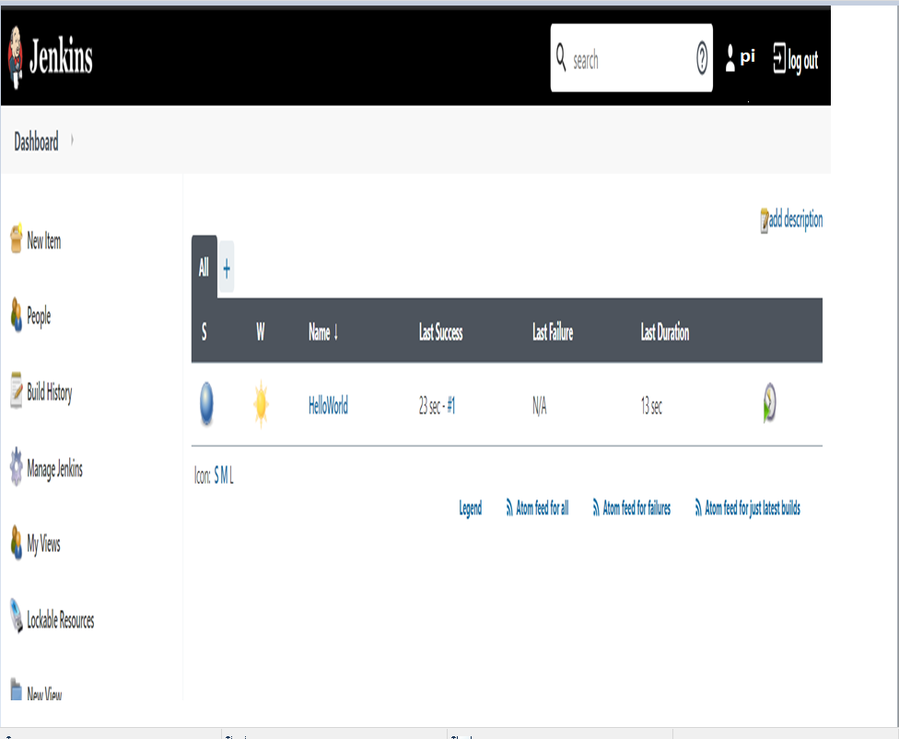

**Task2: Configure git SCM**

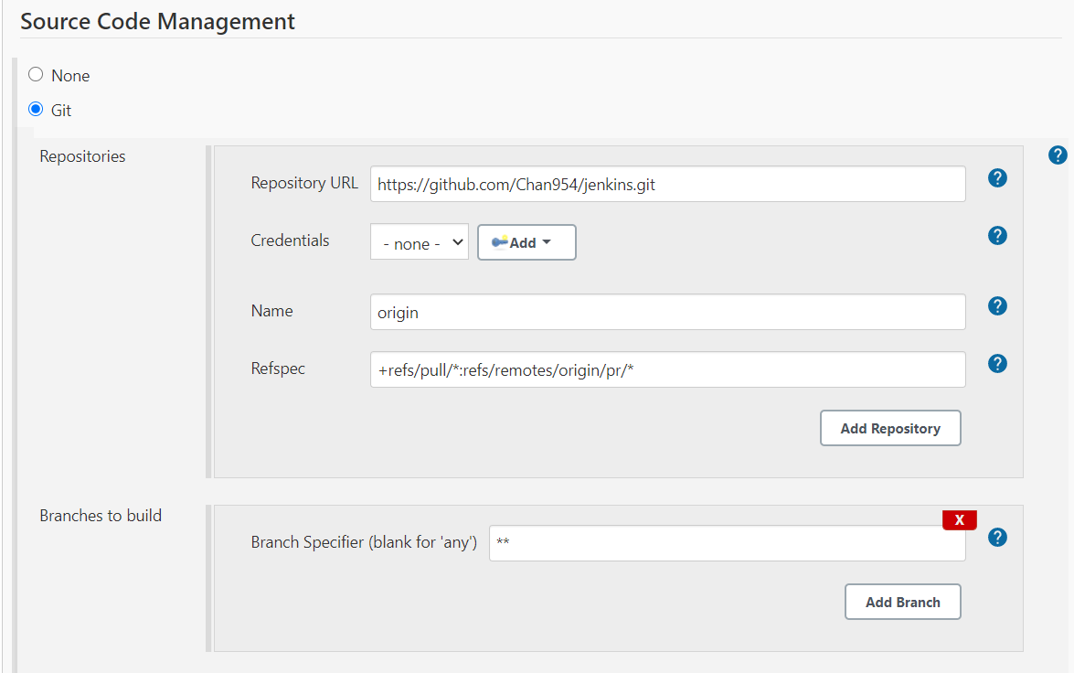

**Add build step-java commands in execute windows batch commands**

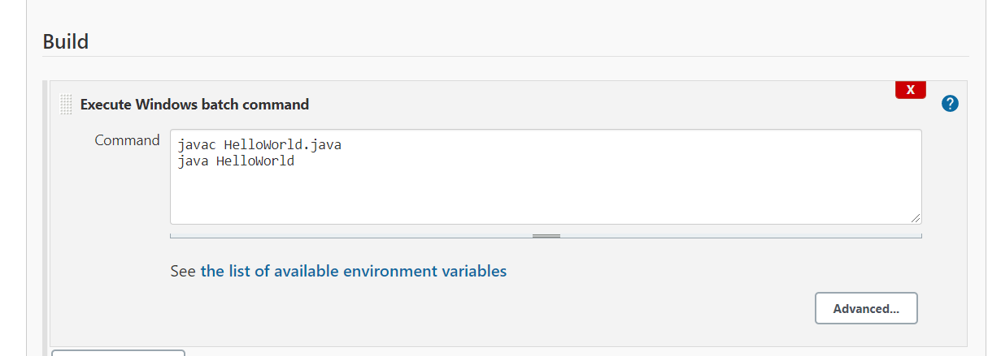

**Ss2: Run a build and show console output**

